

Development of a Mobile Application for the Capital Municipal Council of Bahrain

SUBMITTED BY

Noora Sajjad

Sumaya Majdi

Sara Khalaf

Majeed AlMoathen

SUPERVISOR

Dr. Wasan Shakir Awad

April 2020

MANAMA, KINGDOM OF BAHRAIN

Development of a Mobile Application for the Capital Municipal Council of Bahrain

SUBMITTED BY

Noora Sajjad

Sumaya Majdi

Sara Khalaf

Majeed AlMoathen

A PROJECT IN PARTIAL FULFILMENT OF THE REQUIREMENTS

FOR THE DEGREE OF BACHELOR IN INFORMATION TECHNOLOGY, COLLEGE OF INFORMATION

TECHNOLOGY, AHLIA UNIVERSITY

December 2020

MANAMA, KINGDOM OF BAHRAIN

**AHLIA UNIVERSITY**

**Approval Page**

The project report has been submitted to Ahlia University by Noora Sajjad, Sumaya Majdi, Sara Khalaf and Majeed AlMoathen as a partial fulfillment for the degree of Bachelor Information Technology and has been examined and approved by the examining committee:

1. Supervisor -----------------------------------------------------------------------------

1. Internal Examiner #1 ----------------------------------------------------------------

1. Internal Examiner #2 ----------------------------------------------------------------

Date: ________________

Table of Contents

List of Figures 6

List of Tables 7

Abstract 8

Chapter 1: Introduction 8

1.1 Background 8

1.2 Problem statement 9

1.3 Project Objectives 10

1.4 Project Significance 11

1.5 Project Outcome 11

1.6 Report structure 12

Chapter 2: Requirements and Analysis 12

2.1 Requirements collection 12

2.2 Requirements 12

2.2.1 Technical requirements 12

2.2.2 Primary requirements 12

2.2.3 Secondary requirements 12

2.3 Analysis 12

2.3.1 Functional requirements 12

2.3.2 Nonfunctional requirements 12

2.4 Mobile application user flow (Use case) and Entity relation diagram (ERD) 6 12

2.5 Summary 12

Chapter 3: System Design 12

3.1 Interface design 12

3.2 Summary 12

Chapter 4: Implementation and Testing 12

4.1 Website/Application integration 12

4.2 Interface layout creation 12

4.2.1 Lists layouts 12

4.3 Development 12

4.3.1 JSON 12

4.3.2 Processing JSON files 13

4.3.3 Sharing function 13

4.4 Testing & Debugging 13

4.4.1 Testing methods 13

4.4.2 Testing results 13

4.5 Summary 13

Chapter 5: Deployment and Maintenance 13

5.1 Deployment 13

5.2 Maintenance 13

5.3 Summary 13

Chapter 6: Conclusions 13

6.1 Difficulties 13

6.2 Future work 13

References 13

# List of Figures

**No table of figures entries found.**

# List of Tables

**No table of figures entries found.**

# Abstract

# Chapter 1: Introduction

## 1.1 Background

In recent years, government bodies have adapted their services into online services hence implementing an e-government area. In Bahrain, the Capital Municipal Council have requested to implement their services online so that Bahraini citizens can benefit from them and become aware of their available services. Our research has found that other Municipal government bodies from different countries have also made their services available online in the form of mobile applications. This gave us the idea of creating a mobile application for the Capital Municipal Council as it provides portability and online availability.

There are many countries that have created mobile applications for their municipal government bodies; we have looked at Riyadh *(Riyadh Municipality - Information Technology and e-services Department 2018)*, Kuwait *(ConceptTech Telecom Company-Kuwait 2014)*, Jeddah *(Ibtikar Technologies, Co. Ltd. 2014)*, Mosman *(Mosman Municipal Council, 2019)* and New Delhi *(New Delhi Municipal Council, 2019)* municipal government mobile applications. We understood from observing these apps i.e. their functionalities and user interfaces, how to design the mobile application for the Capital Municipal Council of Bahrain. For example, all apps demonstrated a basic static splash screen of their municipal logo however, only two of them *(Riyadh Municipality - Information Technology and e-services Department 2018)* and *(Mosman Municipal Council, 2019)* displayed the homescreen with the available services at startup, which was more appealing and professional. All of the apps except the *(New Delhi Municipal Council, 2019)* and *(Mosman Municipal Council, 2019)* apps used a side menu for navigation; *(Mosman Municipal Council, 2019)* used a dashboard and tabs for navigation. In addition, all of the apps displayed the news and about us features commonly, which indicates their importance. Therefore, all of this portrays to possible solutions for designing and coding our app for the Capital Municipal Council of Bahrain.

Not much research has been done regarding development of municipal government applications however, one research was done by (Tong Cao and Jie Luee, 2007) on the application of a mobile government system for the Beijing Municipal Government where they stated “Governments have long recognized in the potential of ICT to bring about fundamental changes, not only in the way they function but also in their relations with other organizations, social groups and individuals. Both in their relationship with the citizen, inter-organizational arrangements, and in intra-organizational activities, ICT and Internet technology in particular, as seemed to promise enormous opportunities to reinvent government, to increase efficiency and effectiveness in public sector” therefore indicating on the importance of developing mobile applications for government bodies, where in this case is for the municipal government.

## 1.2 Problem statement

In the era of technology, soon governmental facilities are forced to follow the rest of the world in an effort to effectively engage with citizens. In the this project we are proposing to develop an a cross platform application for the Capital Municipal Council which will be focused on providing a variety of services to the user such as reaching out to the council members, accessing news and upcoming events organized by the council, status of ongoing and future projects and sharing their feedback by engaging in surveys. This application will make it easier for both parties to gather information and communicate with each other.

## 1.3 Project Objectives

1. To design and develop a ‘Projects’ Module for the Capital Municipal Council of Bahrain
2. To design and develop an ‘Events’ Module for the Capital Municipal Council of Bahrain
3. To design and develop a ‘News’ Module for the Capital Municipal Council of Bahrain
4. To design and develop an ‘About Us’ Module for the Capital Municipal Council of Bahrain
5. To design and develop a ‘Council Members’ Module for the Capital Municipal Council of Bahrain
6. To develop and design a front-end UI for all the modules
7. To model a database for the News, Events, Council Members, About Us and Projects Modules
8. To develop the database using the most efficient platform
9. To design and develop a backend web portal for the Capital Municipal Council of Bahrain
10. To decide on a hybrid framework to host the mobile application
11. To implement an external API for the ‘Survey’ module
12. To implement an external API for the ‘Complaints and Suggestions’ module and link it to the ‘Tawasul’ mobile application

## 1.4 Project Significance

This project will benefit all the parties involved, this application will give anyone with a smart phone the ability to share their feedback by filling out surveys and be aware of current projects and events conducted by the council. It will also give out information about council members and ways to reach out and communicate with them.

The council comity will have a better understanding of their audience which ultimately leads to improving their services and fulfilling their goals.

## 1.5 Project Outcome

The outcome of this project will be a mobile application designed and implemented based on the specifications and requirements given by the Capital Municipal Council board members.

## 1.6 Report structure

# Chapter 2: Requirements and Analysis

## 2.1 Requirements collection

## 2.2 Requirements

### 2.2.1 Technical requirements

### 2.2.2 Primary requirements

### 2.2.3 Secondary requirements

## 2.3 Analysis

### 2.3.1 Functional requirements

### 2.3.2 Nonfunctional requirements

## 2.4 Mobile application user flow (Use case) and Entity relation diagram (ERD)

## 2.5 Summary

# Chapter 3: System Design

## 3.1 Interface design

## 3.2 Summary

# Chapter 4: Project Plan, Implementation and Testing

## 4.1 Software Functions/Features

The software functions designed were based on the requirements of the capital municipal member clients. The below are how the requirements were implemented as functions in the overall system.

### 4.4.1 Ionic Client-Side Application

1. Display Projects
   1. Display Projects List
   2. Display Specific Project Details
2. Display News
   1. Display Latest News Card List
   2. Display Details of Specific News
3. Complaints and Suggestions Functions
   1. Redirect to store of mobile operating system (i.e. for iOS – Apple Store and Android – Play Store) to the third-party application “Tawasul” page
4. Events Functions
   1. List of available events
      1. In-app browser to Eventbrite website that displays event details
5. Display Council Members
   1. Display list of Council Members
   2. Display Details of specific council member
6. Survey Functions
   1. List of Available of surveys
      1. In-app browser to google form survey
7. Display About Us
   1. Display Details of About Us sections

### 4.4.2 Server-Side Website

1. Login System
   1. Login using pre-given username and password
      1. Authenticate login username and password
   2. Session started
      1. Auto logout feature
2. Dashboard
   1. News Page
      1. Edit News Details
   2. Projects Page
      1. Edit Projects Details
   3. Council Members Page
      1. Edit Council Members Details
   4. About Us Page
      1. Edit About Us Details
   5. Events Page
      1. Add event from Eventbrite
      2. Remove event
   6. Survey Page
      1. Create survey using google forms
      2. Remove survey

## 4.2 Risk Plan

1 – Lowest

10 – Highest

|  |  |  |  |  |
| --- | --- | --- | --- | --- |
| ***Risk*** | **Probability (1-10)** | **Impact (1-10)** | **Priority (1-10)** | **Mitigation Plan** |
| *Losing a project member* | 2 | 9 | 10 | * Ensure that each team member has current copies of all team members' activities. * Ensure that GitHub repo always has up to date project work |
| *Task takes longer than expected* | 7 | 9 | 10 | * Ask Clients/Ahlia University/Supervisor for an extension * Prioritize modules and functions so that the important parts are completed fully or as much as possible |
| *Hardware breaking down* | 3 | 5 | 9 | * Ensure that each team member has current copies of all team members' activities. * Ensure that GitHub repo always has up to date project work * Find a replacement for hardware |
| *Unrealistic Schedules* | 6 | 8 | 9 | * Ensure there is a proper project plan * Ensure that there is priority module planning |
| *Poor/In adequate Project Planning* | 5 | 9 | 8 | * Revisit Requirements * Have project plan revised by supervisor/external party |
| *GitHub Repo shuts down or server is down* | 1 | 9 | 10 | * Ensure there is a local copy of project on all individual's PCs |
| *Insufficient time for the supervisor to provide feedback on the layout and composition of the report* | 5 | 8 | 8 | * Self-Revise the report * Have team members revise the report multiple times * Find another party to revise the report |
| *Coding Compatibilities with different modules* | 4 | 7 | 8 | * Read the update features for each Ionic version before updating to ensure compatibility * Do quick testing after significant coding changes |
| *Inexperienced or unknown coding for a module* | 7 | 9 | 9 | * Refer to online resources * Refer to official guides * Ask supervisor or experts for assistance |
| *Communication issues between team members* | 2 | 9 | 9 | * Ensure that different modes of communication available * Ensure that all members are aware of their responsibilities |
| *Communication issue between project members and client* | 2 | 9 | 9 | * Ensure that different modes of communication available * Try to schedule regular meetings with clients * Email updates if clients unavailable |

(Table – Risk Assessment)

### 4.2.1 Performance Issues

This project could lead to a variety of performance issues. A number of people can use the application framework at the same time. If too many users are involved in the application, network problems and data integrity may arise. To ensure that no other section of the software is accessed when it is updated, we need exclusive access to information. When other users need access to the stored data, we need to ensure that any exclusive lock is removed.

In addition, due to time constraints, each subsystem works independently, but the connection between the Ionic mobile front-end application and the database does not work. The backend website is therefore unable to update the information on the Ionic mobile application UI.

### 4.2.2 Management and Technical Constraints

The team is compromised by a group of university students with diverse programming and technical backgrounds. Most of them have experience programming in HTML, CSS and PHP, so there are very few limitations in this area of expertise. Although few of the members have basic knowledge of the Ionic framework language, there will be many constraints in this area. None of the team members have any prior knowledge in this problem area, whether they are dealing with government bodies or software development, which restrict our project domain. However, all members of the team have some experience in developing websites, which has led to limited constraints in this area.

Management is accomplished in part through e-mails and WhatsApp, because many participants have varying and sometimes overlapping schedules. Each member shall hold the other members liable for the part of their work. The team leader sets dates and times for meetings and designates tasks to the members of the team. Communication would have been the biggest obstacle for the project manager and would have interacted with the team members on an almost regular basis.

### 4.2.3 Project Monitoring and Control Mechanisms

In order to keep track of the status of the project, electronic communication via e-mail and WhatsApp is required. Team members must update their part of the work of the other members so that all members can see the code on a regular basis. This ensures that the reports submitted at this time are a fair snapshot of the project. In addition, the project manager must hold a weekly meeting to connect face to face and to review the status of each activity assigned to the team member. Then there's a chance for the team leader to give a snapshot of the other members' tasks.

Another effective control mechanism is the use of the Git source control, which uses an online repository to synchronize and keep each other's work up to date. In addition, it would help to recover and allow other members to have access to each other's work without constantly meeting up and manually syncing each other's work. We chose GitHub as our online repository because it is currently the most popular Git repository on the Internet. Allows team members to work and then "pull" up-to-date work from GitHub and then "push" their completed task back to the repository.

The project used two repositories for each subsystem: one for the Ionic mobile application subsystem and the other for the backend website. The URLs for each are: https:/github.com/noonz66/CMC-Project-for-499-Ionic and https:/github.com/noonz66/CMC-Project-for-499-Website. One of the team members was assigned to manage the repository by which their role was to keep track of changes and commit any changes accordingly to ensure that there are no clashes and incompatibilities within any updated codes.

## 4.3 Work Breakdown Structure

Capital Municipal Council for Bahrain Services System Project

1. Project Management
   1. Monitor Progress
      1. Schedule meetings
   2. Assess risks
      1. Identify risks
      2. Mitigation plan
   3. Evaluate results
      1. Check to ensure everyone understands the requirements
      2. Identify and help to improve vulnerable areas
2. Requirements
   1. Analyzing Functional Requirements
   2. Analyzing Non-functional requirements
      1. Security
      2. Ease of use
3. System Design
   1. User interface of mobile application
      1. View Projects
      2. View News
      3. Complaints and suggestions redirect
      4. View and attend events using Eventbrite
      5. View council members
      6. View About Us
      7. View and conduct surveys using google forms
   2. User interface of backend website
      1. Login system
      2. Create news article (form)
      3. Create projects article (form)
      4. Add and remove event
      5. Create council member data (form)
      6. Create About Us data (form)
      7. Create survey using google form 3rd party and remove
   3. Database
      1. Create news table
      2. Create projects table
      3. Create accounts table
      4. Create events table
      5. Create council members table
      6. Create about us table
      7. Create survey table
4. Testing/Debugging
   1. Unit Testing
      1. White box
      2. Black box
   2. System Testing
   3. Acceptance Testing
5. Deployment

## 4.4 Responsibility Matrix

|  |  |  |  |  |
| --- | --- | --- | --- | --- |
| Task | Noora Sajjad | Sara Khalaf | Sumaya Majdi | Majeed AlMoathen |
| **Ionic Mobile Application** |  | | | |
| Create Home Menu | x |  |  |  |
| Create News Module |  |  |  | x |
| Create Projects Module |  | x |  |  |
| Create Side Menu |  |  | x |  |
| Create About Us Module | x |  |  |  |
| Create Council Members Module | x |  |  | x |
| Create Complaints and suggestions redirect |  |  |  |  |
| Create Events Module |  |  |  |  |
| Create Survey Module |  |  |  |  |
| Create connection between Ionic mobile application and database for each page | x | x | x | x |
| **Backend Website** |  | | | |
| Create Login/Logout Module | x |  |  |  |
| Create Home page with dashboard | x |  |  |  |
| Create News Edit Module |  |  |  | x |
| Create Council Members Edit Module |  |  |  | x |
| Create About Us Edit Module |  |  | x |  |
| Create Projects Edit Module |  | x |  |  |
| Create Survey Edit Module |  |  |  |  |
| Create Events Edit Module |  |  |  |  |
| **Database** |  | | | |
| Design Database Design | x | x | x | x |
| Create About Us Table |  | x | x |  |
| Create Accounts Table | x |  |  |  |
| Create News Table |  | x | x |  |
| Create Projects Table |  | x | x |  |
| Create council members Table |  | x | x |  |
| Create events Table |  | x | x |  |
| Create survey Table |  | x | x |  |
| **Writing the Report** |  | | | |
| Chapter 1 | x | x | x | x |
| Chapter 2: 2.1 |  |  |  | x |
| Chapter 2: 2.2 |  |  | x |  |
| Chapter 2: 2.3 |  | x |  |  |
| Chapter 2: 2.4 | x |  |  |  |
| Chapter 3 |  |  |  | x |
| Chapter 4 | x |  |  |  |
| Chapter 5 |  | x |  |  |
| Chapter 6 |  |  | x |  |
| Abstract |  |  |  |  |

(Table – Responsibility Matrix)

## 4.5 Pert Chart

Table – Pert Chart

## 4.6 Implementation

The implementation phase of the project has by far been the most challenging of the phases of this project. Many hopes and dreams were shattered. Because of the significant time constraint, many functions that initially seemed trivial to implement became very time consuming to implement. Much functionality has been left out either due to time or to manpower as many project members had other projects during the same period of time. Below is a list of functions that we intended to implement. The highlighted ones are the ones that were actually implemented as of the time of this writing.

### 4.6.1 Functions Implemented (Highlighted)

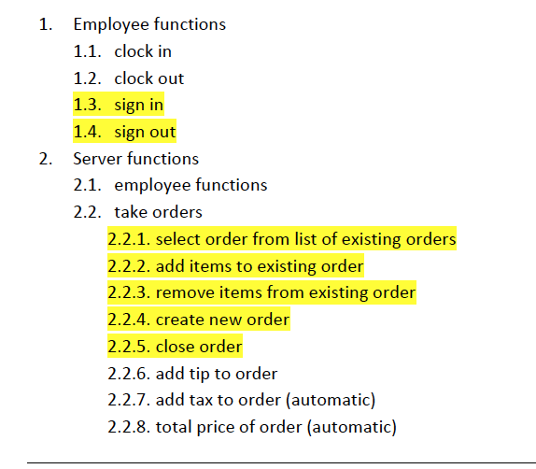

Despite the many functions that were not implemented, much of the framework for the unimplemented functions exists and can easily be added to in the future. The graphical user interface was by far the most time consuming task of the entire project. Perhaps using a builder of some sort, would have proven more efficient.

### 4.6.2 User Interface Design

Because of the nature of our project, an intuitive graphical user interface is required. Initially designed by Jacob Boniface, the user interface design below is the JAVA Swing equivalent of the earlier design. There are a few alterations that had to be made. The buttons on the far right side on each screen have been removed and put onto a single menu accessible after login. On the first screen visible to the user we have removed all buttons except the sign in button. The functionality that was originally on this particular screen has been moved to subsequent menus and screens. In addition, we have added the clock functionality to every screen in the program so that no matter which screen an employee is viewing, he or she will be able to keep track of time.

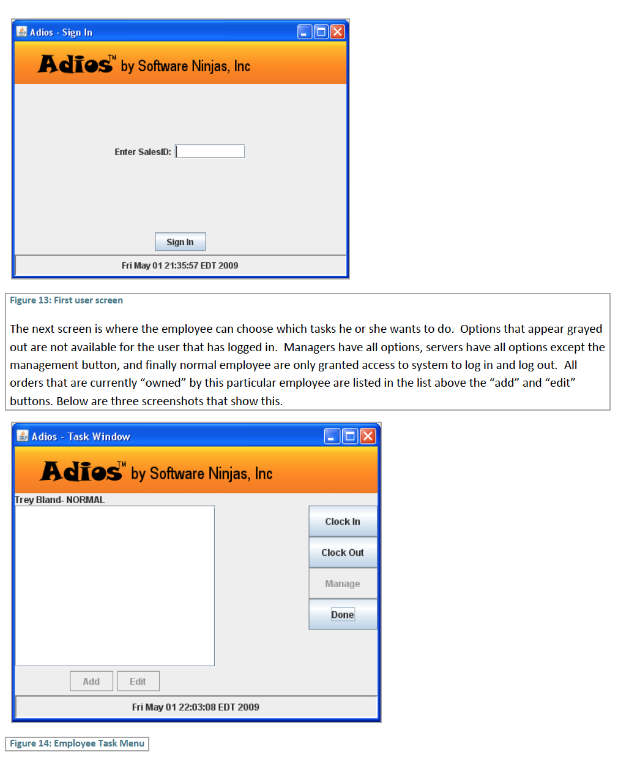

## 4.7 Test Plan

The test plan for the Adios system can be summed up into our three major goals: reliability, security, and usability. Reliability is the first of the goals. The software must be able to do the requested function and perform in a predictable way. The second goal is security. The program must provide the correct functionality to the employee authorized to execute those functions. Lastly, the third and most important goal is usability. We want to make sure our product does more the simply work; we want it to be usable.

Reliability and security testing can be accommodated by merely constructing a few test cases and comparing what the result should be versus what the result is. Usability testing, however, is completely different. Usability testing would require some domain experts to use the software and perhaps even deploy the software in a restaurant environment. Due to the time constraints of the project we were unable to perform any formal usability testing.

Test cases were created to test adding, deleting, and editing both items and employees. Specifically these test cases make certain that employee and items are stored and retrieved from the database correctly. Test cases were also generated to perform boundary testing on how many entries could be successfully added or updated. In addition, test cases where created to verify the function of the compare class, which is used to validate input. The table of test cases listed on the following page shows what kinds of tests were performed on the “add new employee” function, the intended results, and the actual results.

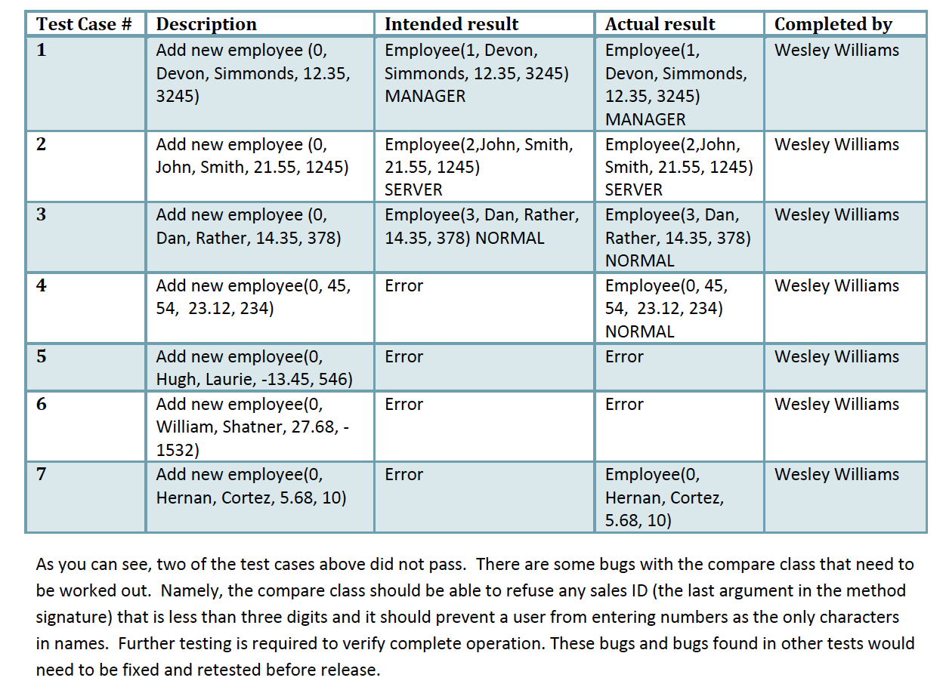

## 4.8 Implementation & Testing - Major Problems

By far the biggest challenge encountered was time constraints. Implementation takes an extraordinary amount of time and a large amount of coordination. Scheduling project meetings around every group member’s schedule has been nearly impossible. Many of the group members were unable to devote the amount of focus that the implementation stage required. Both the former and the latter problem may be more of an issue in the academic environment where priorities of the different group members are skewed in a variety of directions. Another issue that cropped up was knowledge of the JAVA programming language. At least two of the four group members were unfamiliar with JAVA’s Swing API, which is JAVA’s primary user interface package. Again, this may not be as much of an issue in software engineering outside the academic arena.

One of tools we found very useful, in situations where member responsibilities need to be hashed out, is the responsibility matrix. It has really been the only tool that has allowed us to continue making progress. Everyone is assigned a task, and everyone is held accountable for the completion of their assigned task. It also allows us to track tasks that need to be done. The responsibility matrix has proven to be an invaluable tool in the software engineering process

## 4.9 Tools

|  |  |
| --- | --- |
| Tool Used | Description |
| Computer or Laptop | Any hardware that can support and use the digital tools listed below. Any Operating System whether Windows or MacOS is applicable. |
| Microsoft Visual Studio Code | Code Editor for both Ionic and Website coding |
| XAMPP | Web Server Solution from Apache distribution that supports PHP and is used to create the database and host/run backend website. |
| Adobe XD | To design the mobile application UI concept. Prototype Creator. |
| Adobe Illustrator | To design the mobile application UI concept including logo and menu icons. |
| MS Word | Word Processor to type up notes and write up report |

(Table – Tools Required for Implementation)

## Website/Application integration

The concept of this required the data on the website to be accessible on application, this availed the first obstacle in the development of this application.

…………

……………..

…………………

Below is a high level flow diagram the shows how the data interchange happens.



Figure 4.1: High level flow diagram

## Interface layout creation

To bring the interfaces design discussed in section 3.1 of this report we will be using the XML editor provided by Android studio.

The layouts are based on distinctive structures, Lists (main and tags page), Articles (YouTube, Podcasts and miscellaneous articles), other pages (language selection and errors), and the toolbars.

### 4.3.1 Lists layouts

For the Main page and Tags page the same concept applies, both revolve around the list that contains the information.

1. Main page

In the main page 3 main elements were used surrounded by a linear layout, those elements are, the Progress bar which shows a rotating circular progress notification, the list view containing the article headlines, and the button to go to other pages.



## Development

In this section I will discussing the actual coding done, first we will cover the JSON part which is the most critical part of the entire project, later on I will show the various important main function that were used to develop and bring this application to life.

### 4.3.1 JSON

### 4.3.2 Processing JSON files

### 4.3.3 Sharing function

## Testing & Debugging

### 4.5.1 Testing methods

The test was on 4 devices, the below points were targeted for this

* + Operation system compatibility
  + Screen resolution and effects on font, icons and other items.
  + Language support and text direction

……

All above points were important to go through, following section discusses the results.

### 4.5.2 Testing results

Below table points all the testing conducted, finding and actions.

|  |  |  |
| --- | --- | --- |
| Point of testing | Findings | Action |
| …. | …. | … |
|  |  |  |
|  |  |  |

Table 6.1: Application testing results

## Summary

Chapter four has discussed what could be the most critical phases in application development. We have discussed how the implementation started, ………..

# Chapter 5: Deployment and Maintenance

## 5.1 Deployment

## 5.2 Maintenance

## 5.3 Summary

# Chapter 6: Conclusions

## 6.1 Difficulties

## 6.2 Future work

# References

Riyadh Municipality - Information Technology and e-services Department, 2018. بلدي الرياض. Mobile app. Version 1.3.5. <https://apps.apple.com/bh/app/%D8%A8%D9%84%D8%AF%D9%8A-%D8%A7%D9%84%D8%B1%D9%8A%D8%A7%D8%B6/id1308202626>. Accessed 2 February 2020.

ConceptTech Telecom Company-Kuwait, 2014. المجلس البلدي الكويت. Mobile app. Version 1.2. <https://apps.apple.com/bh/app/%D8%A7%D9%84%D9%85%D8%AC%D9%84%D8%B3-%D8%A7%D9%84%D8%A8%D9%84%D8%AF%D9%8A-%D8%A7%D9%84%D9%83%D9%88%D9%8A%D8%AA/id942374611>. Accessed 2 February 2020.

Ibtikar Technologies, Co. Ltd., 2014. المجلس البلدي بجدة. Mobile app. Version 1.2. <https://apps.apple.com/bh/app/%D8%A7%D9%84%D9%85%D8%AC%D9%84%D8%B3-%D8%A7%D9%84%D8%A8%D9%84%D8%AF%D9%8A-%D8%A8%D8%AC%D8%AF%D8%A9/id1210615464>. Accessed 2 February 2020.

Mosman Municipal Council, 2019. MyMosman. Mobile app. Version 3.1. <https://apps.apple.com/bh/app/mymosman/id1231309688>. Accessed 2 February 2020.

New Delhi Municipal Council, 2019. NDMC-311. Mobile app. Version 1.6. <https://apps.apple.com/bh/app/ndmc-311/id1446242962>. Accessed 2 February 2020.

Tong Cao, J. and Jie Luee, T. (2007). Application of M-government system in Beijing Municipal Government. 2007 IEEE International Conference on Systems, Man and Cybernetics, [online] pp.3220-3224. Available at: <http://ieeexplore.ieee.org/stamp/stamp.jsp?tp=&arnumber=4413962&isnumber=4413561> [Accessed 2 Feb. 2020].